|  |  |
| --- | --- |
| Source ID | URL |
| 629774014 | https://ijece.iaescore.com/index.php/IJECE/issue/archive |
| 658711423 | https://ijeecs.iaescore.com/index.php/IJEECS/issue/archive |

Above website has same structure of website.

1)Got to the website using url .Then you will direct to the website like below.

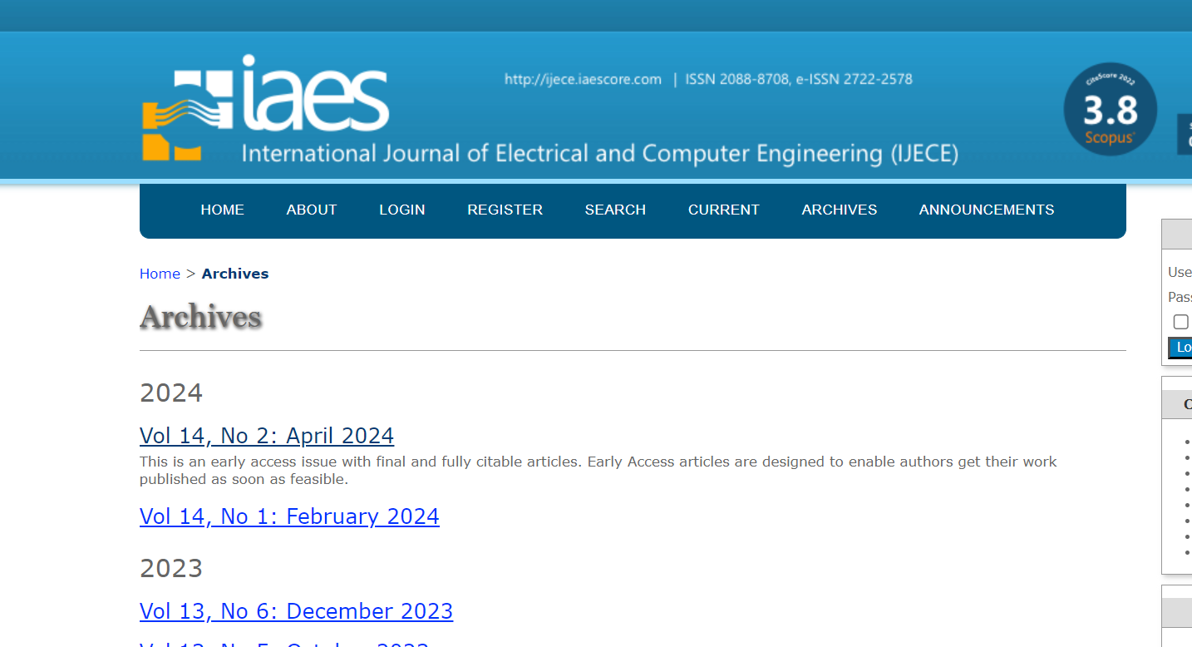

2)Click here

You will direct to the current issue page.

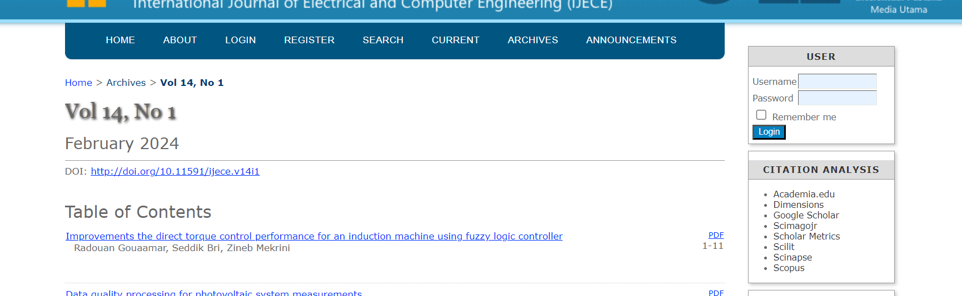

6)Capture page range

7)Capture article title and click

6)Capture year

)5Capture year

4)Capture issue

3)Capture Month

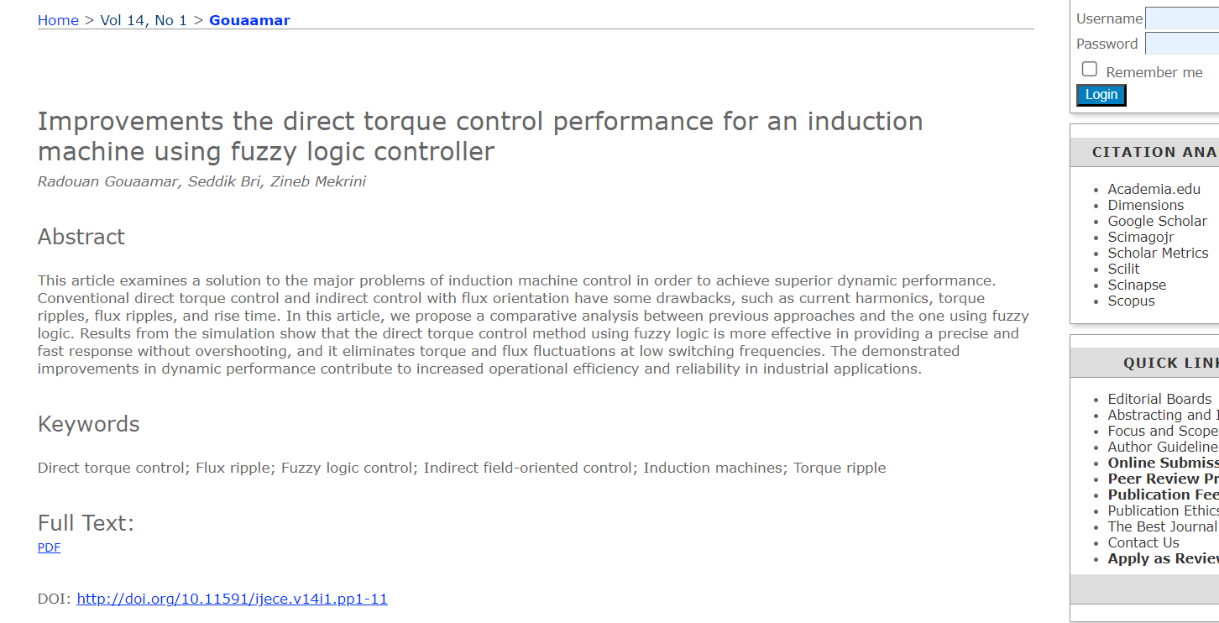

8)Click pdf to download dpdf

8)Capture DOI